## horizontal line

Maximum sum rectangle in a 2D matrix

# **Problem Statements :**

You are given a 2D array, find the maximum sum subarray in it. For example, in the following 2D array, the maximum sum subarray is highlighted with blue rectangle and sum of this subarray is 29.

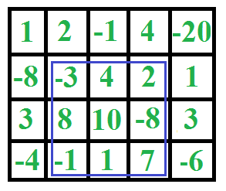

# **Input Format :**

The first line consists of number of test cases T. For each test case, consists two integers n and m as dimension of 2D array and next n lines contain m space separated integers .

# **Constraints :**

1 <= T <= 1000000  
1 <= n,m <= 10  
0 <= A[i] <= 1000

# **Output Format :**

Print the maximum subarray sum.

**Sample Input :**

1

4 5

1 2 -1 -4 -20

-8 -3 4 2 1

3 8 10 1 3

-4 -1 1 7 -6

# **Sample Output :**

29

**Time LImit :**

1 sec

**Explanation :**